**COVID-**

**19**

**Medical Certificate**

In accordance with the ordinance of the Ministry of Health, Welfare and Sport

regarding SARS-

CoV-

2

diagnostics

This is to certify that

Name: NAAM

BSN/Passport: NUMMER

Born: 00-00-0000 in: Plaats, Nederland

Has been tested for the presence of SARS-

CoV-

2

by RT-PCR

THE COVID-19 PCR NASAL/ORAL SPECIMEN SWAB TEST

Sample date 00-00-20 12:00 - Result date 01-00-2020 12:00

**Status report of infection on the date of the test**

SARS-

CoV-

2

pos: neg: .

______________________________

Place: Baarn Date:01-00-2020

Signature and seal of the certifying medical doctor

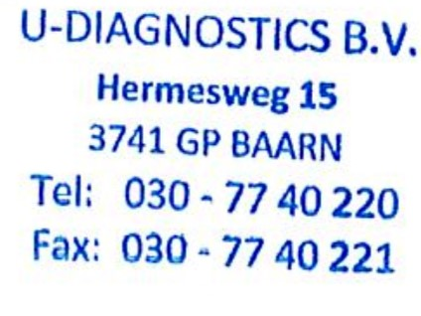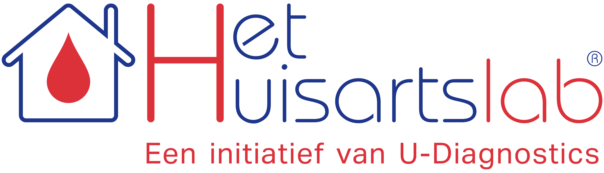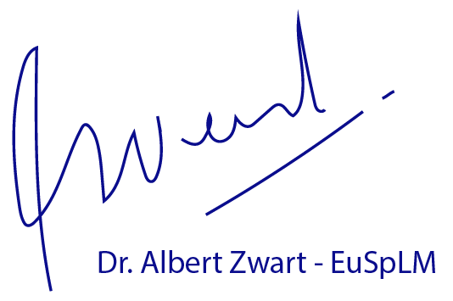

id: 40000000